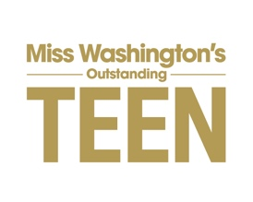

PINK CROWN CLUB
is
LOOKING FOR SPONSORS, WILL YOU SUPPORT THE MWAOTEEN PROGRAM?
Only 100 spots available at our tax deductible level!
www.mwoteen.org

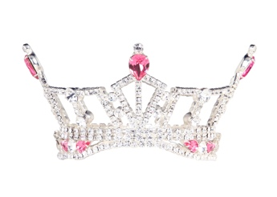

We need your help!

Miss Washington’s Outstanding Teen Program Volunteers work hard each year to raise funds for the young ladies who compete in the MWAOTeen Program.
Our goal is to fund all awards, prizes and scholarship dollars through donations, sponsorships and in-kind contributions. In an attempt to do this, we are pleased to announce our donation options for you:
Level 1 ~ PINK CROWN CLUB - The purpose of the PINK CROWN CLUB is to enlist the support of One Hundred (100) people who support the mission of the Miss Washington’s Outstanding Teen Program. Participating in the Miss America’s Outstanding Teen system not only helps them pay for college and prepare for a career, it also provides an opportunity to gain additional life experience, working on issues of importance to society, enhancing their personal and professional skills and developing their performance-related and other talents. We believe that education is key to a person’s success and we are proud to be able to support MWAOTeen in their efforts and also assist so many outstanding teens with the achievement of their educational dreams. This level of sponsorship is $100 and is tax deductible. The funds are strictly set aside for SCHOLARSHIPS. As a member of the PINK CROWN CLUB, 100% of your donation will be earmarked for scholarship purposes and, therefore, 100% deductible.
Level 2 ~ PINK CROWN CLUB - This level of sponsorship is for cash donations that will go towards the awards and cash prizes that candidates win at the completion of the pageant. Ex: included are the Miss Congeniality Award, Top Interview Award, Academic Achievement Award, Top Talent, Fitness Award to name a few. This level ranges from $50 up to $5,000 +.
Level 3 ~ PINK CROWN CLUB - This level of sponsorships are for our In-Kind Contributions We are in need of a variety of in-kind services, Ex: meals for the candidates during pageant weekend, drink beverages, healthy snack options, prizes for our candidates and for our Teen Queen once she is chosen (jewelry sponsor, dress sponsor, appearance attire, fitness sponsor, hair sponsor, nails sponsor, tanning sponsor, dry cleaning sponsor, travel sponsor etc).
The Miss Washington’s Outstanding Teen Program would greatly appreciate your donation and contributions at any level. Please let us know how you would like to be involved in the PINK CROWN CLUB, Level 1, 2, or 3.

NAME(S) FOR PROGRAM BOOK:____________________________________________
CREDIT CARD # (VISA OR MASTERCARD):_____________________________________
NAME (AS IT APPEARS ON CARD):___________________________________________
ADDRESS:_______________________________________________________________
BILLING ZIP CODE:________________EXP:________________3-DIGET CODE: ________

Please email QUESTIONS OR COMPLETED FORM TO MWAOTeen at Lonagraves03@gmail.com Make checks payable to MWSO
Accept our sincere appreciation for helping us strengthen our scholarship program!

With Gratitude
Lona Graves
Executive Director/MWAOTeen Program
1004 1st St NE
Auburn, WA 98002

PINK CROWN CLUB MEMBER BENEFITS:
- RECOGNITION IN THE 2020 PROGRAM BOOK
- RECOGNITION ON SOCIAL MEDIA
- SHOUT OUT RECOGNITION AT THE TEEN PAGEANT
- PERSONALIZED AUTOGRAPHED PHOTO FROM MISS WA & MWAOTEEN 2020 FOR ALL DONATIONS $100 AND ABOVE
- TAX-DEDUCTIBLE FOR LEVEL 1 – 501(c)3 TAX ID # 46-1225780

