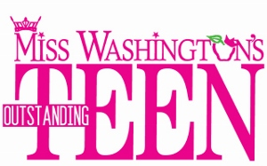
On Stage Questions

Contestant Name and Title:____________________________

Please submit 3 questions to be asked to the other contestants during the Evening Gown/Onstage Question phase of competition. We will choose 1 question out of the 3 to be used during the competition. The questions should be something that you would want to be asked. Have fun with this and be creative.
Please write three questions that you would like to ask the other Miss Washington’s Outstanding Teen contestants. The answers to these questions are judged. All questions will be reviewed and approved by the Miss Washington’s Outstanding Teen officials and the show’s producers. The person answering the question, as well as the audience and judges, will know who the author of the question is. (MWAOTeen reserves the right to make minor changes to the questions, as needed.) EXAMPLES OF A BAD QUESTION: What would be the first thing you do as Miss Washington's Outstanding Teen? Tell us about your platform. Of all of your accomplishments, which one means the most to you? If you were going to be featured on the cover of a magazine, which one would it be and why? What point on the MWAOTeen crown represents you the most? EXAMPLES OF A GOOD QUESTION: Do you think teens today take their teachers for granted? Why or why not? The average teenager in America sends 2000 text messages a month. Should we be concerned that technology is replacing personal contact? How do you make “going green” a part of your daily life? Do you think we should focus more attention on the problems that exist right here in the United States instead of focusing our attention on other nation’s problems? DO NOT SUBMIT ANY OF THE FOLLOWING QUESTIONS: Any questions about the crown and its points, Any questions about contestant platforms. What do you believe is the most important aspect of being Miss Washington’s Outstanding Teen?

Do not submit negative questions. Please think of questions that you would like to answer on stage.

1.

2.

3.

