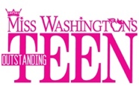

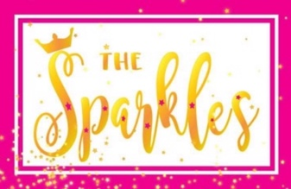
LETTER OF UNDERSTANDING

The Miss Washington’s Outstanding Teen Program (MWATeen) desires to provide an opportunity for young ladies ages 7 to 11 to get a head start on acquiring and/or affirming some of life’s necessary tools, which we all need to navigate everyday life. The following rules will help the Princesses to understand what behaviors are required of them by our organization. Please read and discuss these requirements with your Sparkles young lady.

Miss Washington’s Outstanding Teen Sparkles will conduct themselves at all times with dignity, grace, and the good manners of young women who exemplify the integrity of American young ladies.

A Sparkles young lady will show respect for herself and those around her. She will address all adults with their titles. Examples: “Mrs. Lucy”, unless directed otherwise by the adult.
A Sparkles young lady will be truthful and honest.

A Sparkles young lady will read a book of her choice at least 20 minutes every day.
Additionally, a Sparkles young lady will study hard in school and complete her homework assignments.

A Sparkles young lady must observe all Rules and Regulations from the time of her arrival at Teen Forum and the Miss Washington’s Outstanding Teen (MWAOT) headquarters hotel until the time of her departure.

A Sparkles young lady must be accompanied by a parent/guardian at all times.

A Sparkles young lady will not participate in any media interviews or pose for any media photographs or participate in any other type of publicity, without clearing it with the Miss Washington Outstanding Teen Director, Lona Graves.

A Sparkles young lady will not make appearances in her community wearing her crown unless she is making an official appearance with her Teen Mentor.

A Sparkles young lady must be accompanied by a Parent(s) or Guardian to and from pageant activities.

I HAVE READ AND UNDERSTAND THE ABOVE.

Princess_________________________________________Date___________

Parent/Grandparent/Guardian_________________________ Date __________

